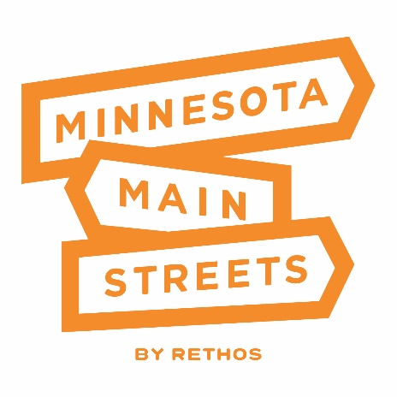
Downtown Assessment Community Application
Basic Information
- Name of Community
- Name of Contact Person Leading Submission
- Role of Contact Person in Community
- Contact Phone
- Contact Email
- Population
- County
Downtown Details
- How many blocks does your downtown cover?
- How many businesses are active in your downtown?
- How many vacant storefronts are in your downtown?
  - Approximately what percentage of your storefronts is this?
- Is there a group or entity committed to downtown activity or revitalization already in existence in your town?
- Are there any community events that happen annually or regularly in your downtown?
  - Please list them along with the type of event it is.
- What is the biggest asset your downtown district has?
- What is the biggest challenge your downtown district is facing?
Community Questions
- What community groups, if any, are active in your community? This is not specific to downtown, but the community at large.
- Are there any dates or major events happening in your community this spring and summer that would hinder a Downtown Assessment taking place? If yes, please explain.
Downtown Assessment Community Partners
- If selected as a 2022 Downtown Assessment Community, you will need a team of 3-4 people who are able to serve as community contacts to help facilitate focus groups, site visits, and provide additional community information.
  - Please list the Assessment team members here
  - Note: these people can be volunteers, or city staff, elected officials, CVB employees, Chamber Employees, downtown business owners, or anyone else with a connection to downtown and willingness to support this project.
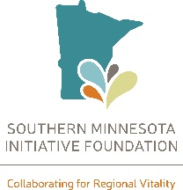
Narrative on Community Proposal
- In 4-6 sentences, share why a Downtown Assessment could be important for your community, and why you’re applying to take part in this project.
- Provide any documents as an attachment that support your application. These can be photos, letters of support, or promotional materials. (This is encouraged but not required.)

