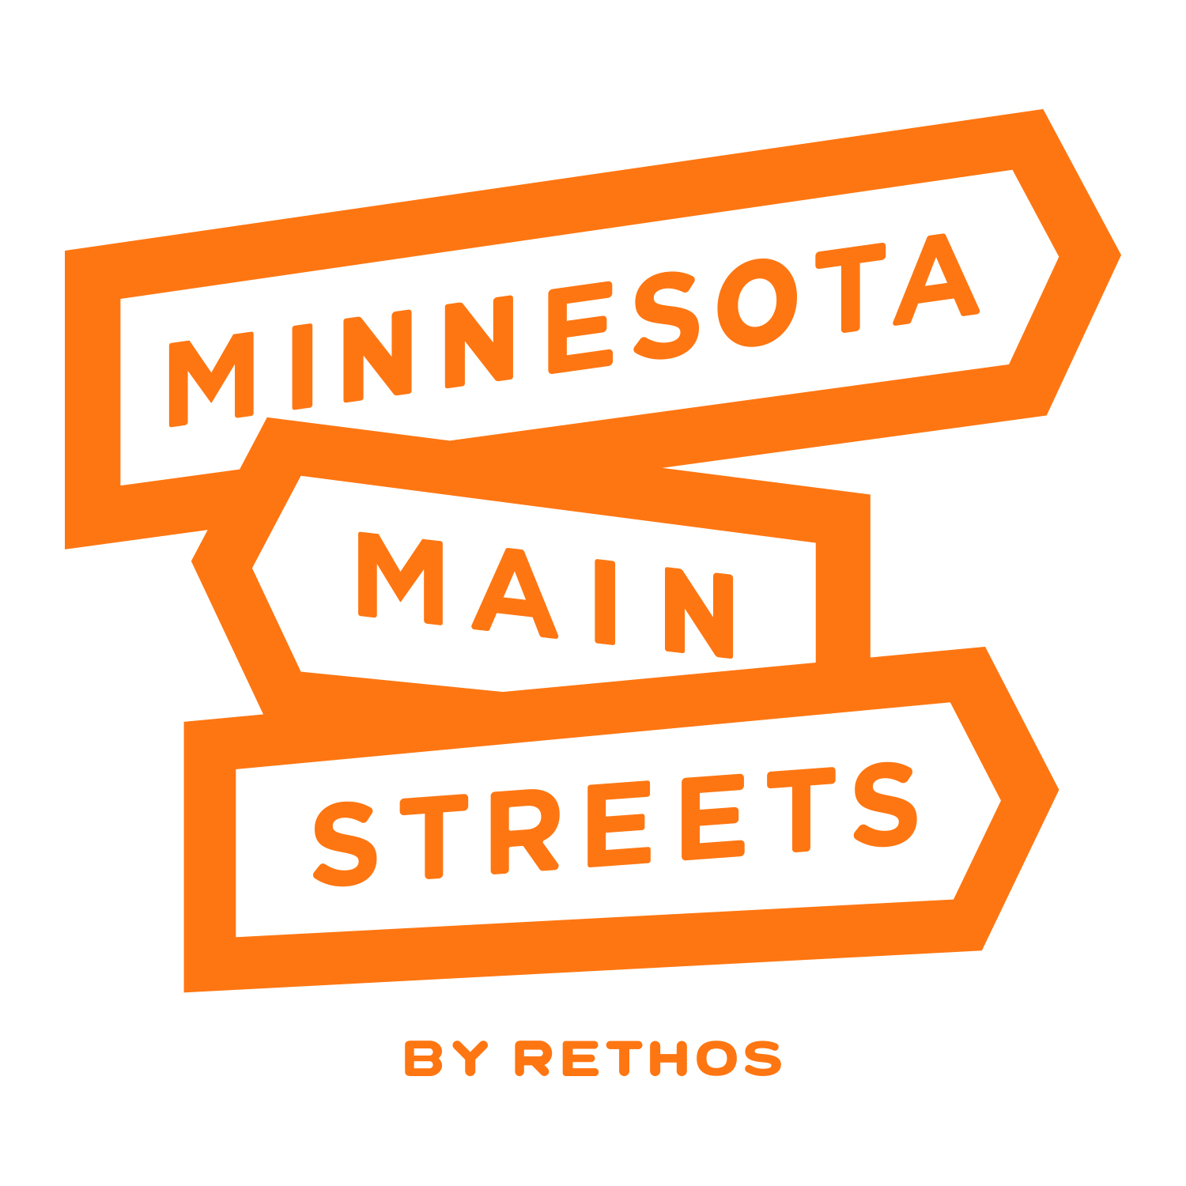

**2025 MMS State Conference Hotel Information:**

Although Duluth has several hotel options throughout the city, the following are nearest and dearest to Lincoln Park.

**ROOM BLOCKS WITH SPECIAL PRICING:**

**NOTE: All rooms booked with special pricing must be booked no later than May 14. After that, special pricing will not be honored.**

**Radisson Duluth Harborview**

*505 W Superior Street*

Located on the western edge of downtown Duluth, this hotel is perfect for those taking public transportation since nearly every bus that goes past this hotel will take you directly into Lincoln Park in about the same time it will take you to drive and park. Driving time, approximately 5 - 7 minutes to Lincoln Park. Note to directors: This hotel is also 7 blocks from the Zeitgeist building, which is walkable in about 10 minutes (opposite direction from Lincoln Park), with 4 coffee shops along the way.

To book these rooms, call 1-800-333-3333 and provide the group name **MN Main Street State Conference** or use this link using the same group name: <https://www.choicehotels.com/reservations/groups/SK29R6.> All rooms booked at the listed prices have a two-night minimum stay.

Mix of Double Queen or Single King Bed/Hill View (Weds-Thurs) - $149+tax

*No weekend availability for these rooms*

Mix of Double Queen or Single King Bed/Lakeview (Weds-Thurs) - $189+tax

*Weekend (Fri-Sat) availability at $319+tax*

To view amenities and room types: [Radisson Hotel Duluth-Harborview | Hotel in Duluth, MN](https://www.choicehotels.com/minnesota/duluth/radisson-hotels/mn287?mc=llgoxxpx)

**Pier B:**

*800 W Railroad Street*

Located on the waterfront, this hotel is equidistant between Lincoln Park and Canal Park. Public transportation is tricky from this hotel but there is a paved bike trail ride to Lincoln Park via the Cross City Trail which would take you roughly 10 minutes, or if you are driving or taking a Lyft/Uber, it is just minutes away. Driving time is approximately 5 - 7 minutes to Lincoln Park.

To book these rooms, call 1- 218-482-8888 and provide the group name **MN Main Street State Conference** or use this link using the group code **MNMA0425**: [www.pierbresort.com.](https://www.pierbresort.com) All rooms booked at the listed prices have a two-night minimum stay. A one (1) night deposit will be taken at the time of reservation, per the hotel’s policy.

Two Queen, King, or Two Queen Pet Friendly/Classic View (Weds-Thurs) - $199+tax

*No weekend availability for these rooms*

To view amenities and room types: [Resorts in Duluth MN - Stay at the Award Winning Pier B Resort Hotel](https://www.pierbresort.com/)

**Zenith Basecamp:**

*2631 W Superior Street*

Located at the western end of the Lincoln Park Craft District, Zenith Basecamp is the newest accommodation in Duluth. In true hostel style, the individual sleeping rooms are comfortable but spare with shared restrooms, showers (individual with lockable doors), kitchenette, and communal area, which makes the Basecamp an affordable option and great for getting to know other conference attendees. The room types and costs are listed below, with the pricing extended through the weekend for those staying on after the conference. One parking spot is included per room. Be aware that although there is space next to the building for unloading, non-handicap overnight parking is across Superior Street by Park State Bank.

To book these rooms, **DO NOT register online!** You must call 218-529-8704 or email [hello@zenithbasecamp.com](mailto:hello@zenithbasecamp.com). Since room types are limited, it is best that you have a second choice in mind when booking. Room types are booked first come, first served.

Twin Bunk (1-2 occupancy) - $85.00+tax  
Accessible Queen (1-2 occupancy) - $85.00+tax  
Deluxe Queen (3-4 occupancy) - $150.00+tax

Single Queen (1-2 occupancy) - $85.00+tax

Single Queen + Single Twin (2-3 occupancy) - $135.00+tax

*Weekend availability at the prices above*

**BOUTIQUE OPTIONS:**

Lincoln Park also has some boutique hotels. Although we were unable to gain group pricing from these properties, they are all located right in the heart of the neighborhood within easy walking distance to all meeting locations. Keep in mind that the Duluth tourist season (although year-round), really kicks into high gear after Memorial Day, so booking sooner rather than later is to your benefit for these locations.

**Duluth Press Building Residential Suites,** *1915 W Superior Street* A historic building next door to Dovetail Café: [Duluth Press Building | Residential Suites | Short-term rental units in Duluth's Lincoln Park](https://duluthpressbuilding.com/) $250 - $1200/night

**Enger Lofts,** *1832 W Superior Street* Coffee shop and retail at street level: [Enger Lofts Hotel | Duluth](https://www.engerloftsduluth.com/) $250 - $400/night

**Lincoln Park Boutique Hotel,** *2102 W Superior Street* (no availability at this time, but if you’d like to check for cancellations): [Stylish Boutique Hotel in Lincoln Park Craft District | Duluth, MN](https://www.lincolnparkboutiquehotel.com/)

**BUDGET-MINDED:**

**Motel 6,** *200 S 27th Avenue W* Located right off I-35. You may need to call to place your reservation. [Motel 6 Duluth, MN Hotel in Duluth MN | Motel6.com](https://www.motel6.com/en/home/motels.mn.duluth.9406.html?lid=Local_Milestone_1294&travelAgentNumber=TA001305&corporatePlusNumber=CP792N5W&utm_source=google%20my%20business&utm_medium=listing&utm_campaign=visit%20website)